MDHHS – MCIR Release Notes
Version 2024 – MCIR OLTP 2024 24.2.28 – RFC 232144 Release Date: 02/28/2024

Forecasting & Assessment – 6 Items

- Moderna 25mcg (CVX 311) and Pfizer 10mcg (CVX 310) provided to children aged 11 years to 11 years + 11 months counted for protection. (Ref# 2683)

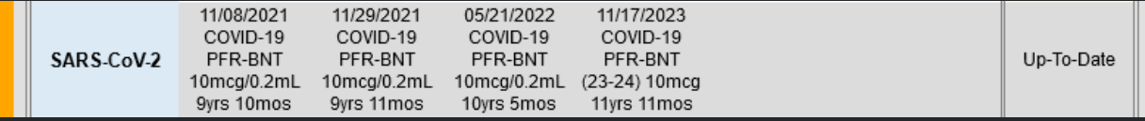

- Forecast dose 2 of Moderna 25mcg 4 weeks, 4 weeks, 8 weeks, and accept two doses of Moderna 25mcg (CVX 311) given 4 weeks apart for protection for children 6 months through 4 years. (Ref# 2690)
Dose 1 administered 11/07/2023
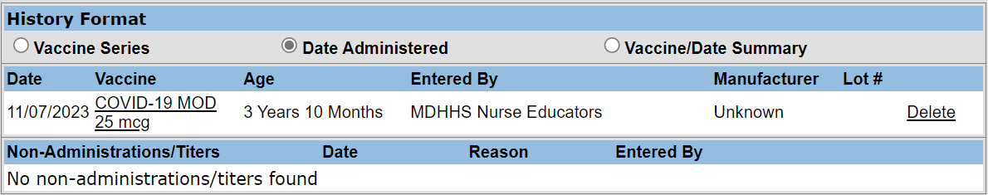
Dose 2 forecasting information
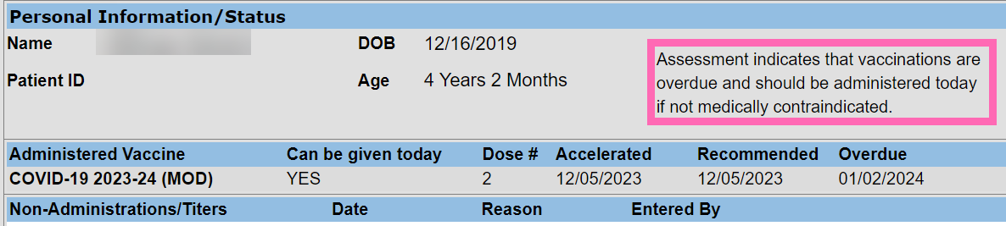
Review the following for CDC guidance information.
https://www.cdc.gov/vaccines/covid-19/downloads/COVID-19-immunization-schedule-ages-6months-older.pdf

- Investigate report of Pfizer second dose being forecast for 4 weeks, 4 weeks, 8 weeks. (Ref# 2709)
Correct forecast reflected as 3 weeks, 3 weeks, 8 weeks.
Does 1 administered 12/14/2023
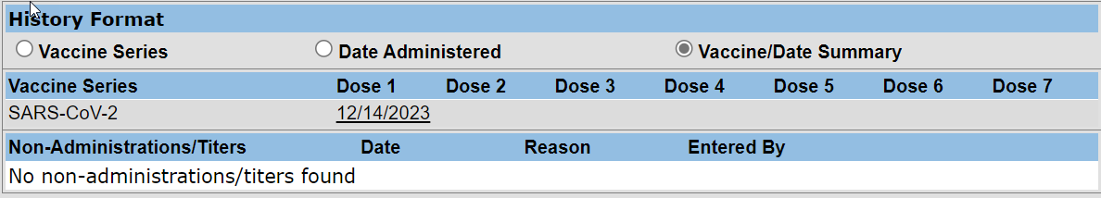
Dose 2 forecasting information
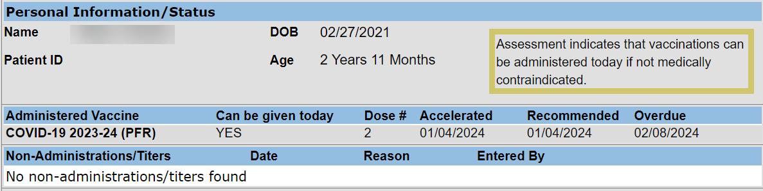

- Investigate COVID-19 forecasting results for mixed series administrations. (Ref# 2717)
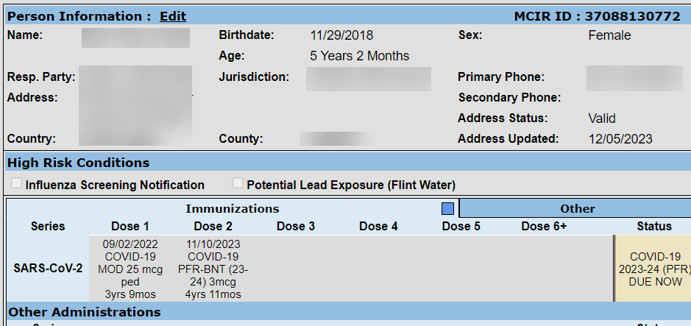
Review the following for CDC guidance information:
Clinical Guidance for COVID-19 Vaccination | CDC

- COVID-19 Pfizer BNT (23-24) 3mcg (CVX 308) is valid does through 4 years of age. (Ref# 2722)

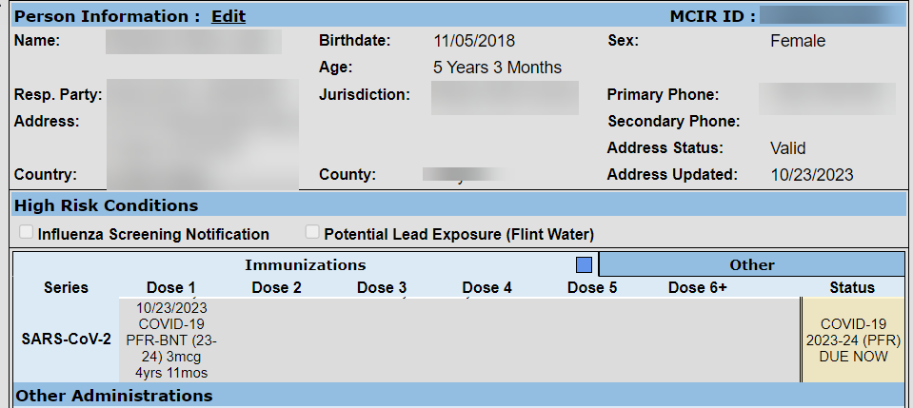
Review the following for CDC guidance information:
Clinical Guidance for COVID-19 Vaccination | CDC

- 10 CVX Codes have been added, please review the link below.
https://mcir.org/wp-content/uploads/2022/05/02.23.24-Vaccine-Codes.xlsx

General – 1 Item

- HL7 Race and Ethnicity warning message, set to expire in February 2024, has been extended to July 2024. The updated warning message will read as follows: (Re# 2786)
“Warning: (RACE_CD or ETHNIC_CD) must be present to add a child and/or an immunization. This will result in message rejection July 2024”

If you have questions or need assistance, please contact your Field Representative or
MCIR SOM Help Desk at MDHHS-MCIRHelp@michigan.gov.

