MDHHS – MCIR Release Notes
Version 2024 – MCIR OLTP 2024 24.11.17 – RFC 246460 Release Date: 11/17/2024

Forecasting & Assessment – 1 Items
- Polio results not displaying on Status screen for providers and childcare facilities. Ref # 3255
Note: This release corrects the Polio assessment issue communicated from the MCIR and Immunization Outreach Education Team on 11/13/2024. The subject read email:
Important: Inaccurate Polio Assessment in the Michigan Care Improvement Registry (MCIR)

Information Screen: Provider
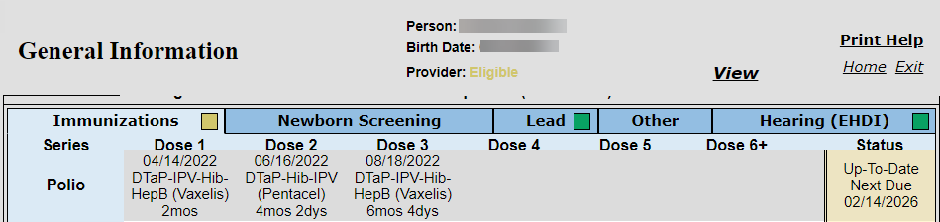

Information Screen: Childcare
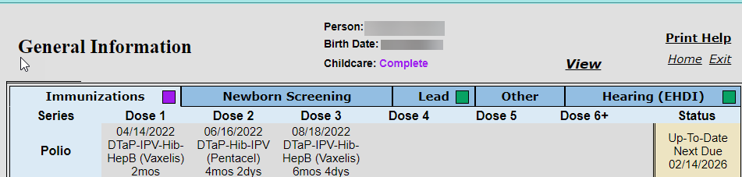

Status Screen: Provider
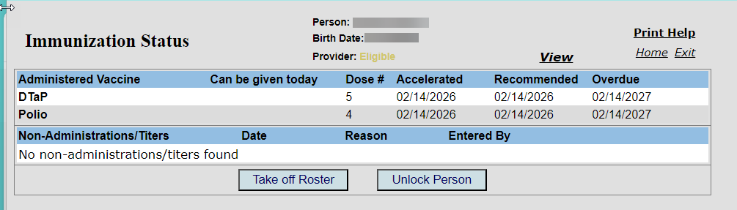

Status Screen: Childcare
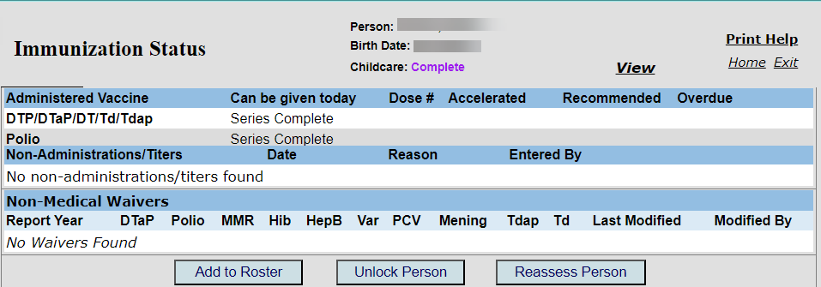

If you have questions or need assistance, please contact your Field Representative or MCIR SOM Help Desk at MDHHS-MCIRHelp@michigan.gov.

